COS30043- Interface Design and Development

6.2D HD- Custom Web Application

Name: Abrar Hossain Chy Toha

ID: 103506608

**1.Introduction:**

For the custom web application, I created an e-commerce site for a grocery store. I used VueJs, Bootstrap 5, JavaScript for front end development and Express Js and MySql for backend development. This document gives comprehensive idea about the project, how to setup the project and what features does the website has. This project has backend which is used to store data. I am using Swinburne’s Mercury server to store the data. This store has 25 products in 5 categories. This project has a homepage where user will land first and there it has some information about some deals and promotions, some high selling products, and some reviews of customers. I added filter functionality to search products based on the requirement. In the product page a user can search product based on the name, max price, min price. Someone can add the product to cart from there. People can see the price of that product as well from the product page. I created card component, and each product will have its own details in each of the card. There is also a like functionality to like the product. But people can’t do it always. First user needs to login and the like button will appear along with the products. And people need to login to add the product to cart. If someone tries to add without logging in, there will be an alert message showing to login first. I added pagination in the product page to see 5 items once at a time. User can move to different pages based on page number or switch to first or last page. Once the product is added to the cart, people can see that from cart page. In the cart page, people can adjust the quantity of the product and remove the product from the cart. And there will be the total price and individual price details of the shopping. User can proceed to checkout from the cart page. In the checkout page, user need to fill all the required details. I added custom validation for the inputs based on the input types. For example: any field can’t be left empty email should be in valid format, card length must be 16, CVV length has to be 3, card expiry date has to be in valid format. If there is any error, it won’t let the user to place order and there will be error messages showing at the bottom of the form. The default payment method is card. If uses changes this to cash on delivery, card details option will disappear. And I added optional notes section as well to write something about the order and its an optional field. Also, in that page total product price, individual price and all the order summaries will be visible. After successful order submission, the user will be moved to homepage. User can check previous orders from order history page. There all the previous orders will be visible along with time, price, quantity. There is a login and registration page to create account and login. I added custom validation for the inputs. And the details will be stored in database with the help of APIs. There is an about page which gives description about the grocery market. And there is a contact page for user to send any enquiries and contact. There is an admin page. Everyone can’t see the admin page except for the dedicated user. I set myself as the dedicated user. Only when I am logged in, I can see the content of the page. In the admin page, dedicated user can add new product, update an existing product, and delete a product. This website is strictly follows mobile first approach. And it supports on three different types of devices. Desktop, mobile and tablet. This project was made by following the usability and accessibility features which made it easy for users to navigate to the desired things what they want to do.

**2.Folder Structure:**

backend

|____app.js: Holds all the APIs written in express js

front-end

|____src

|___assets: All the images used on the website.

|___componets:

|___Footer.vue: Footer component which holds all the links.

|___Nav.vue: Nav component to switch to other pages.

|___Card.vue: Card component to show the products.

|___router

|___index.js: Defined all the routes here.

|___views

|___AboutView.vue: Design of about page.

|___AdminView.vue: Admin page to work on the products.

|___CartView.vue: Cart page to see the list of items

|___CheckoutView.vue: Page to place order

|___ContactView.vue: Contact information page

|___HomeView.vue: Home page of the website

|___LoginView.vue: Login page for the user

|___OrderHistoryView.vue: Used to see previous orders

|___ProductsView.vue: Page to see the products

|___RegisterView.vue: Page to create account

|___App.vue: Root component to bind all the components

**3. Setup and Installation:**

1. This project is developed in vite environment. To run the project, user need to fist create the following tables in mysql database in their own database.

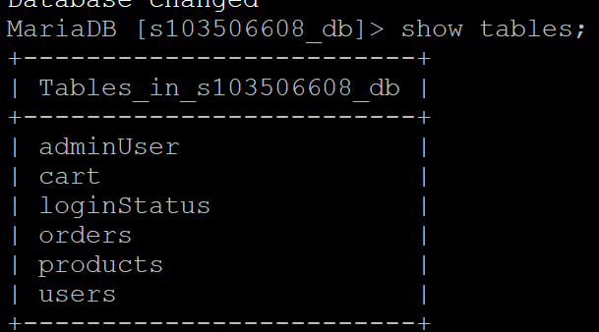

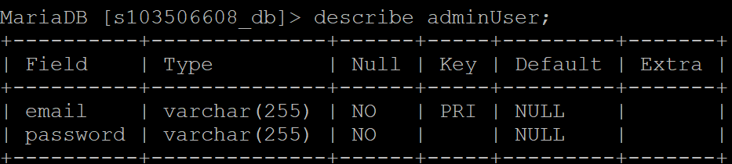 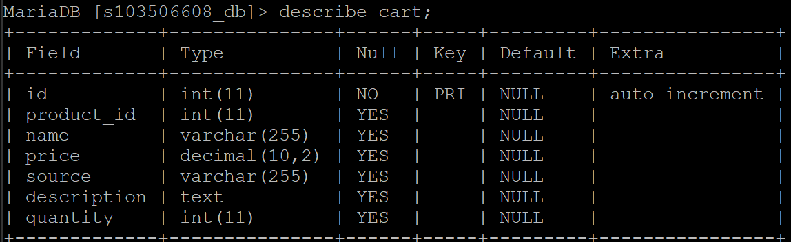

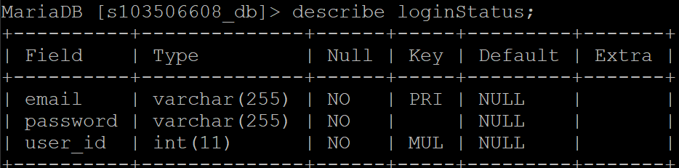

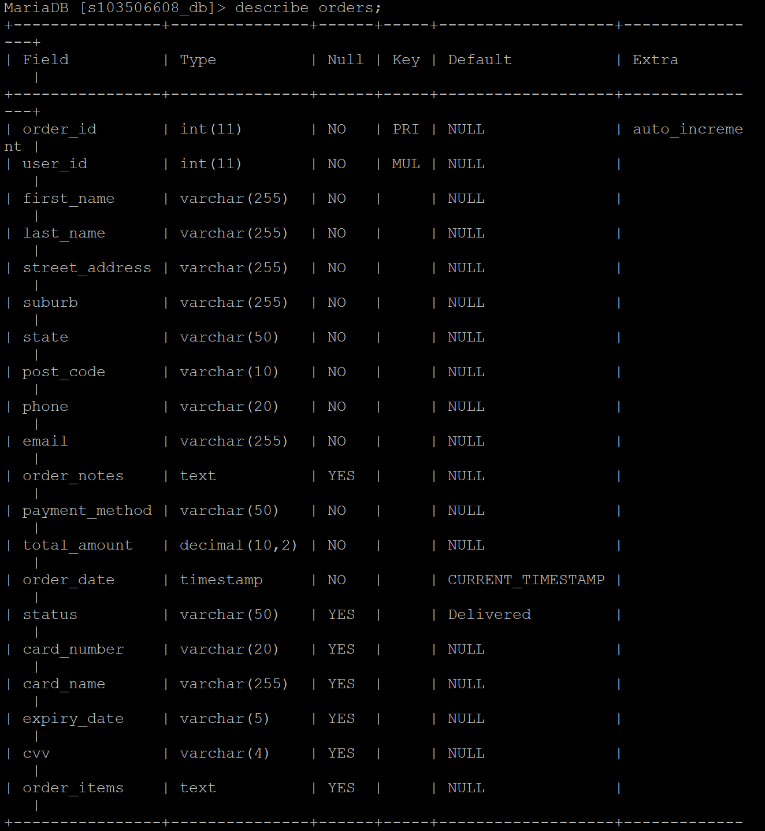

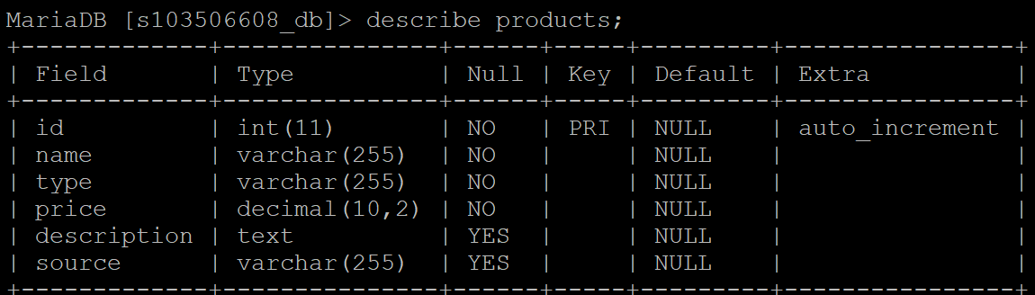

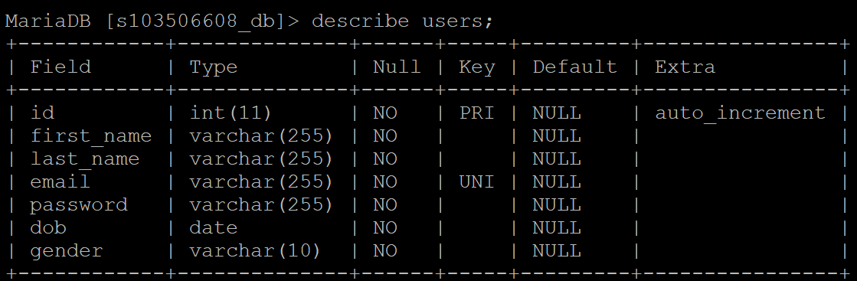

I have added the following 25 products.

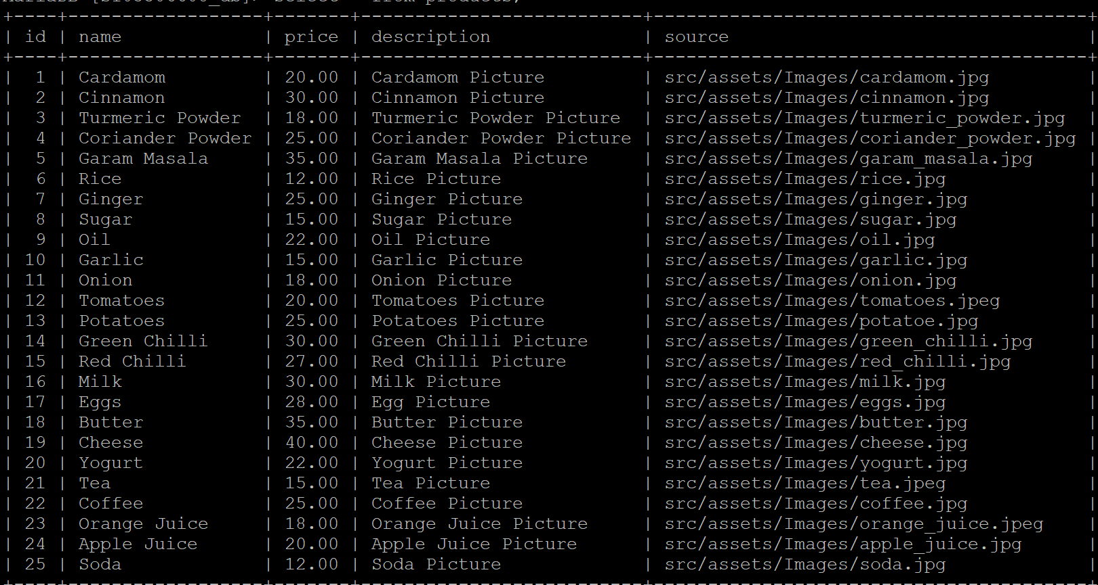

2. After creating the tables and adding the data, user needs to go to each of the folder (front-end, backend) and write the command “npm install”. Then each of their corresponding node modules will be installed.

3. After the installation user can open the command prompt and change the directory to backend folder by writing the command “cd backend”. And the user needs to write the command “node app.js”. It will open the backend express js server.

4. After the backend part, user needs to open the command prompt again and switch to front-end directory. To do this user needs to write “cd front-end”. After moving to the front-end directory, he needs to write “npm run dev”. It will start the project on localhost with the link <http://localhost:xxxx/>. After clicking on the link the project will be visible to the user.

**4. Screenshot of the project:**

4.1 Homepage

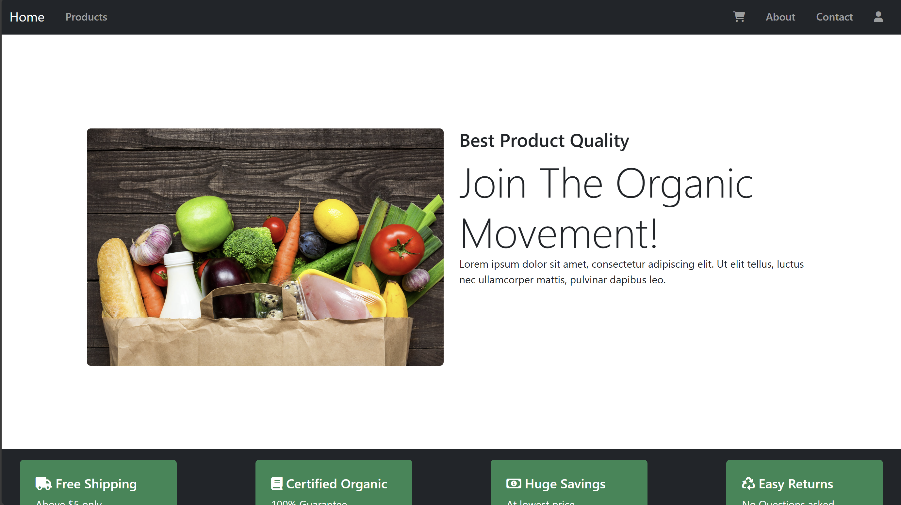



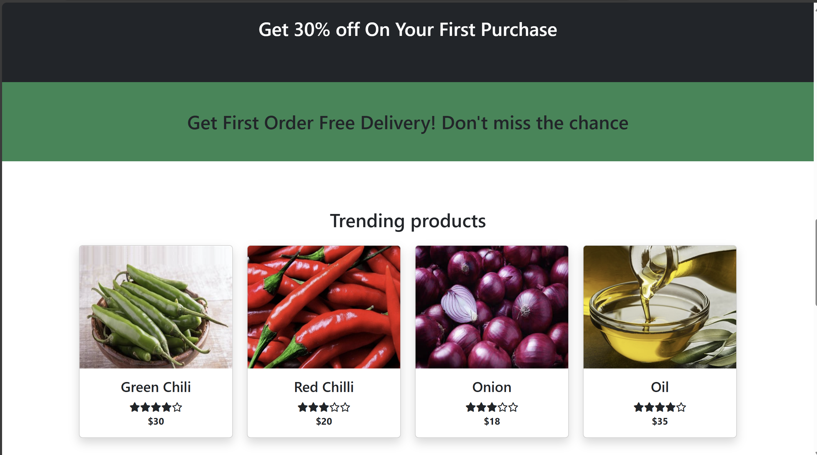

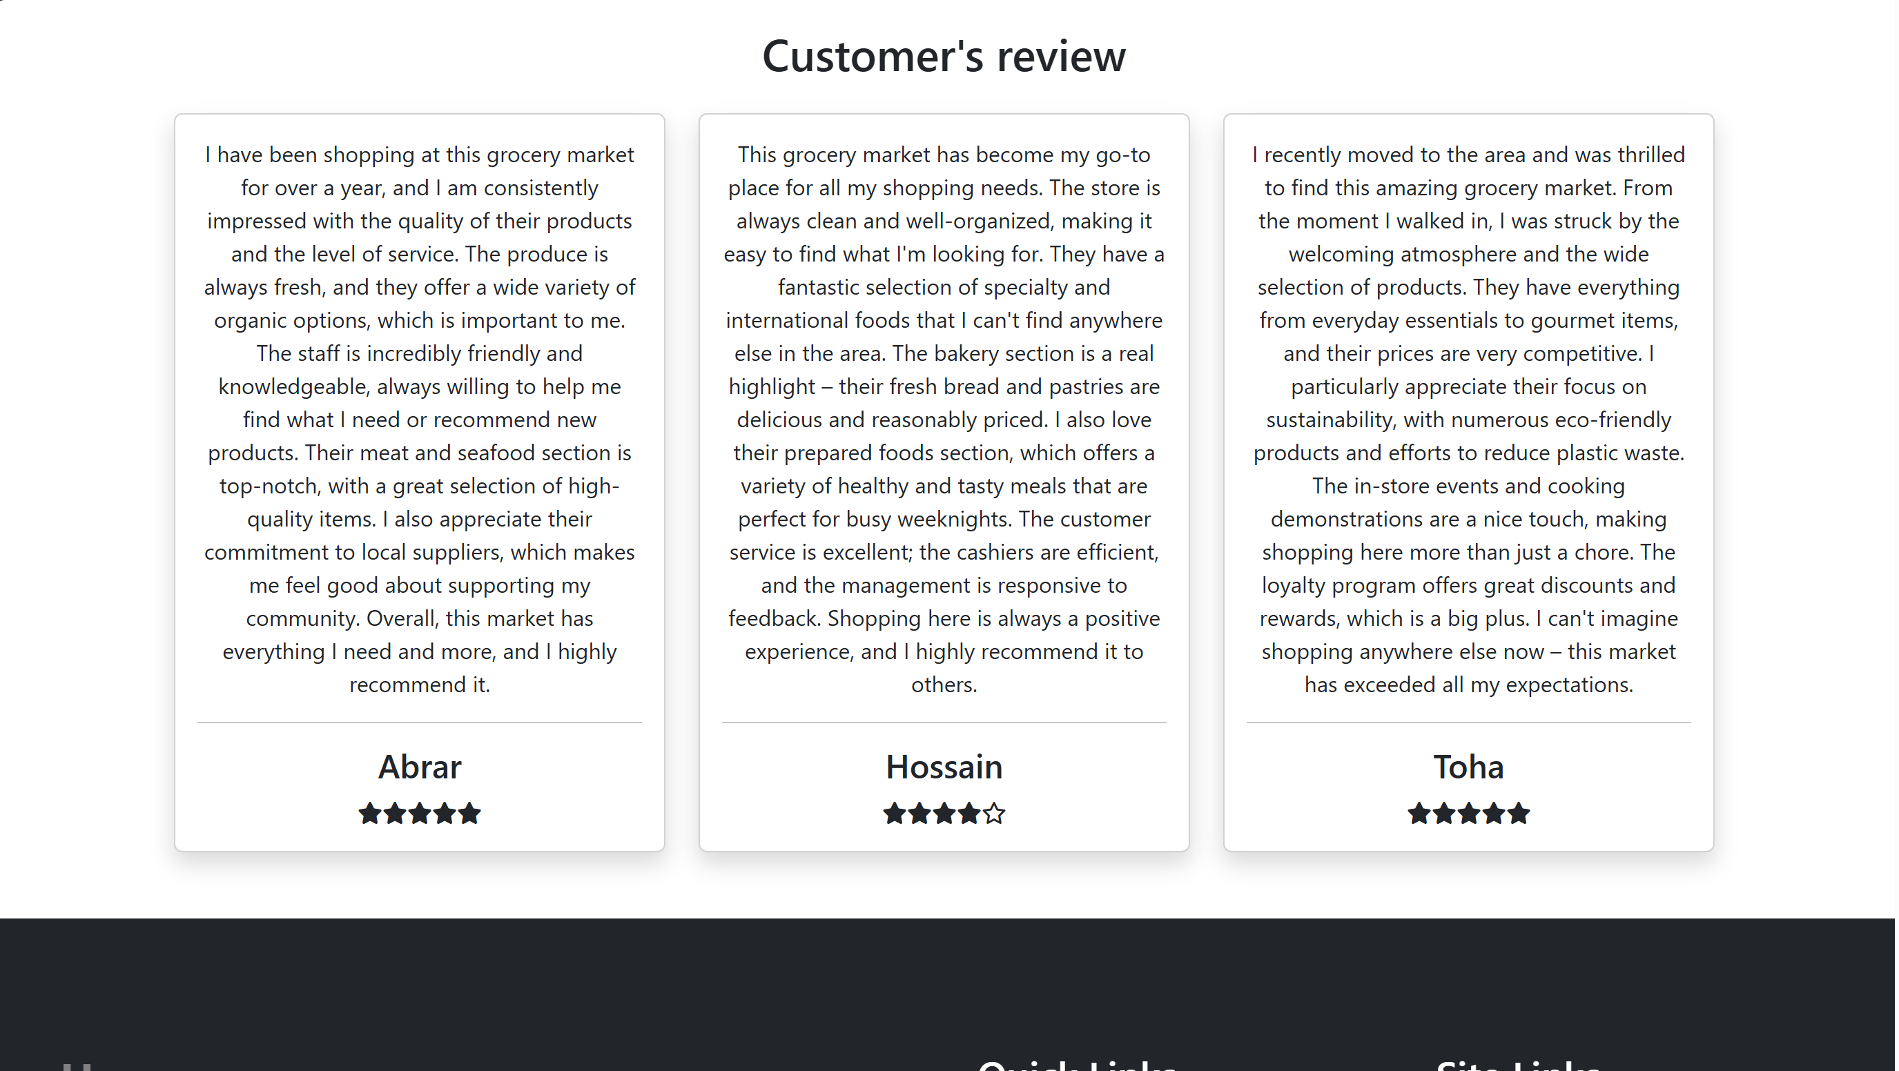

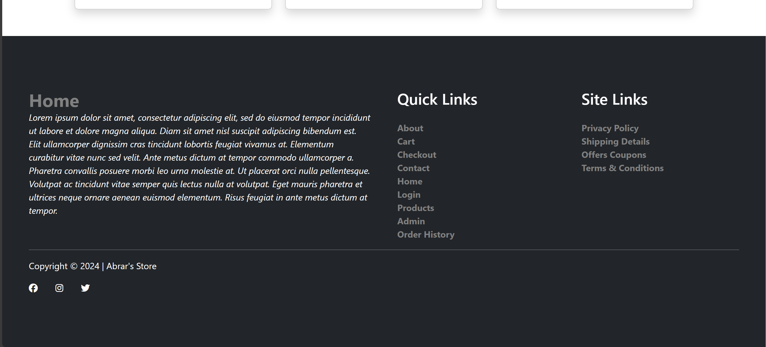

4.2 Product Page

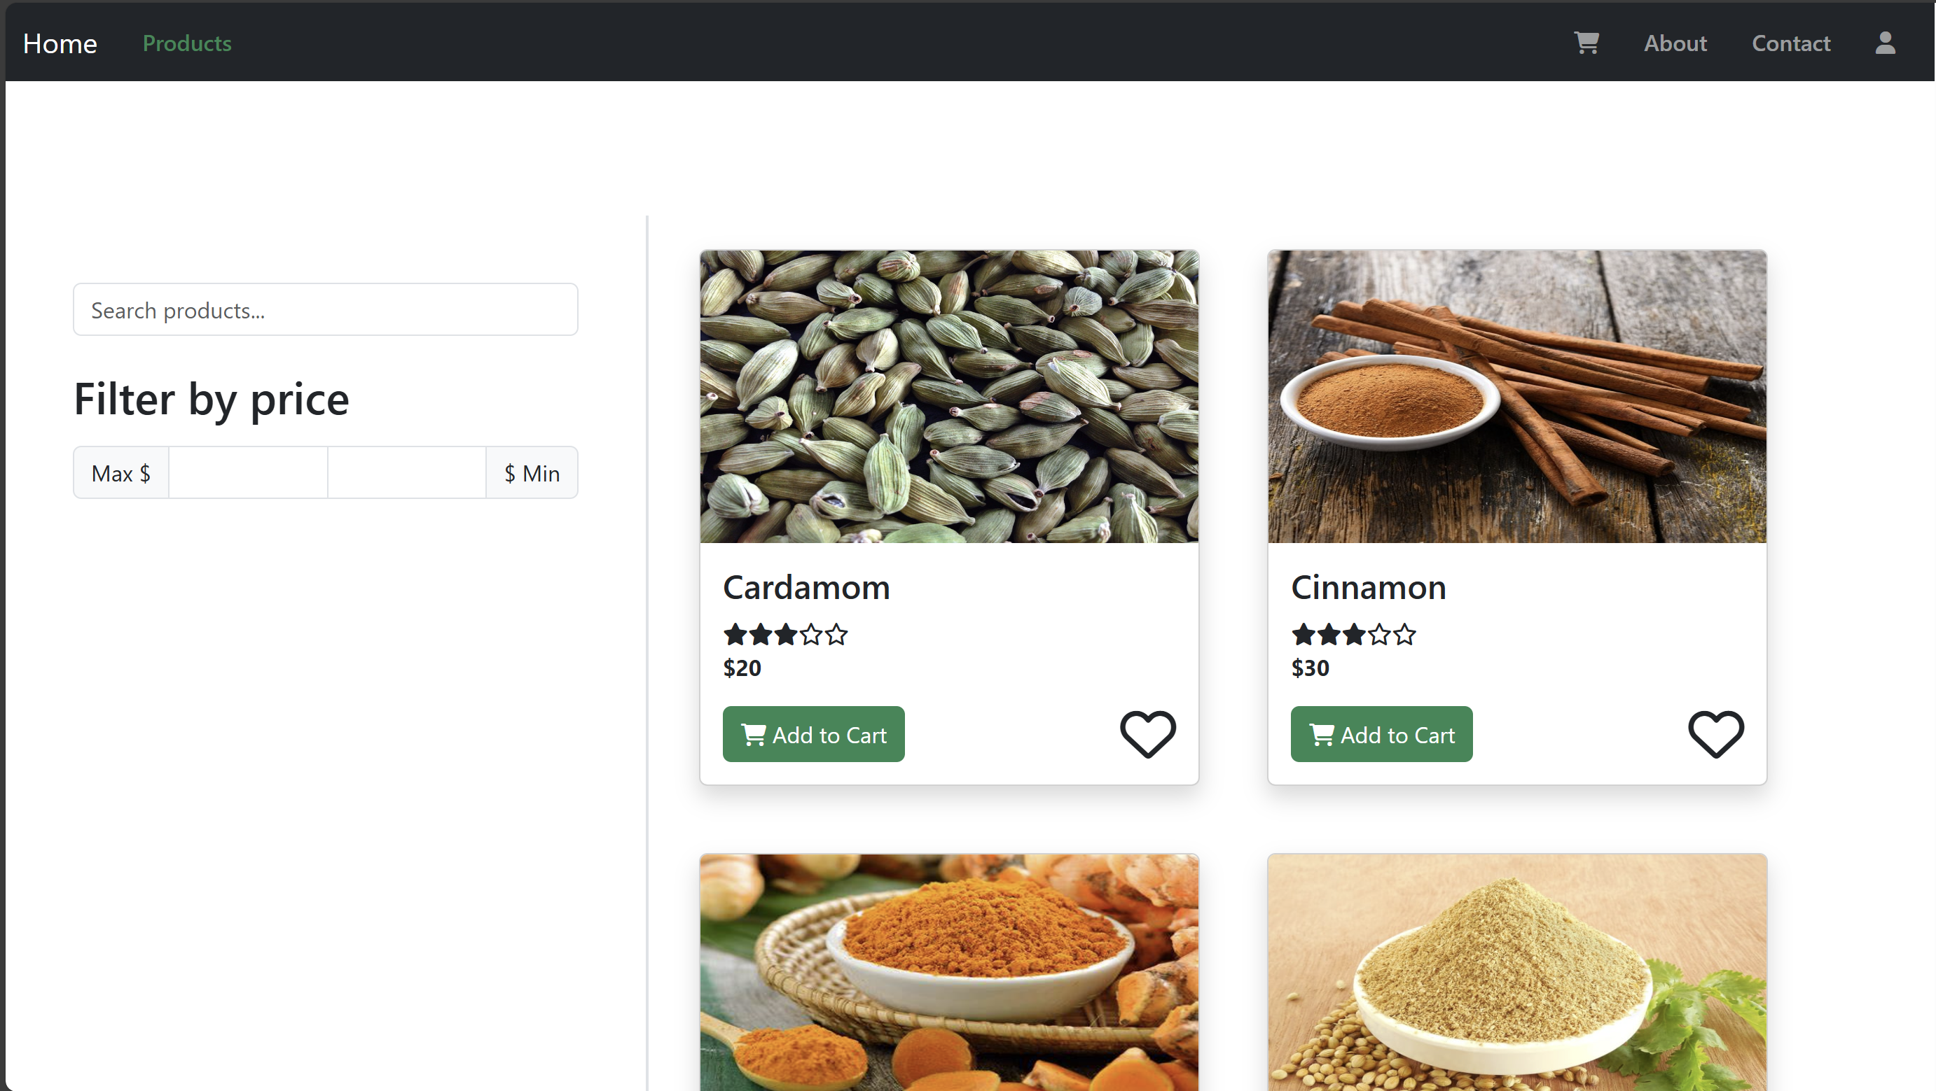

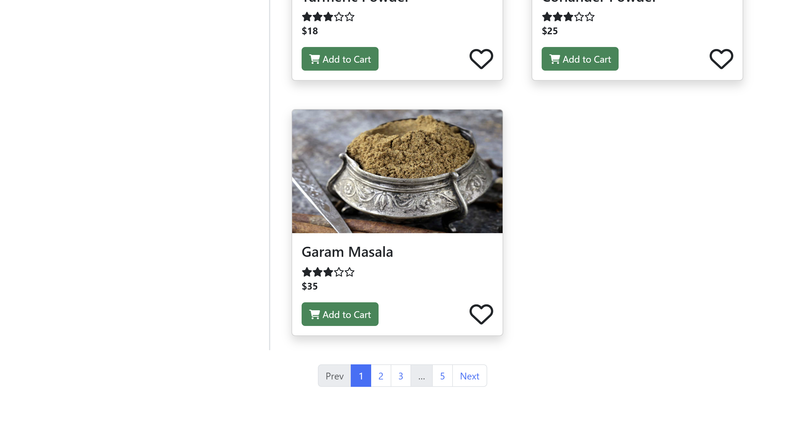

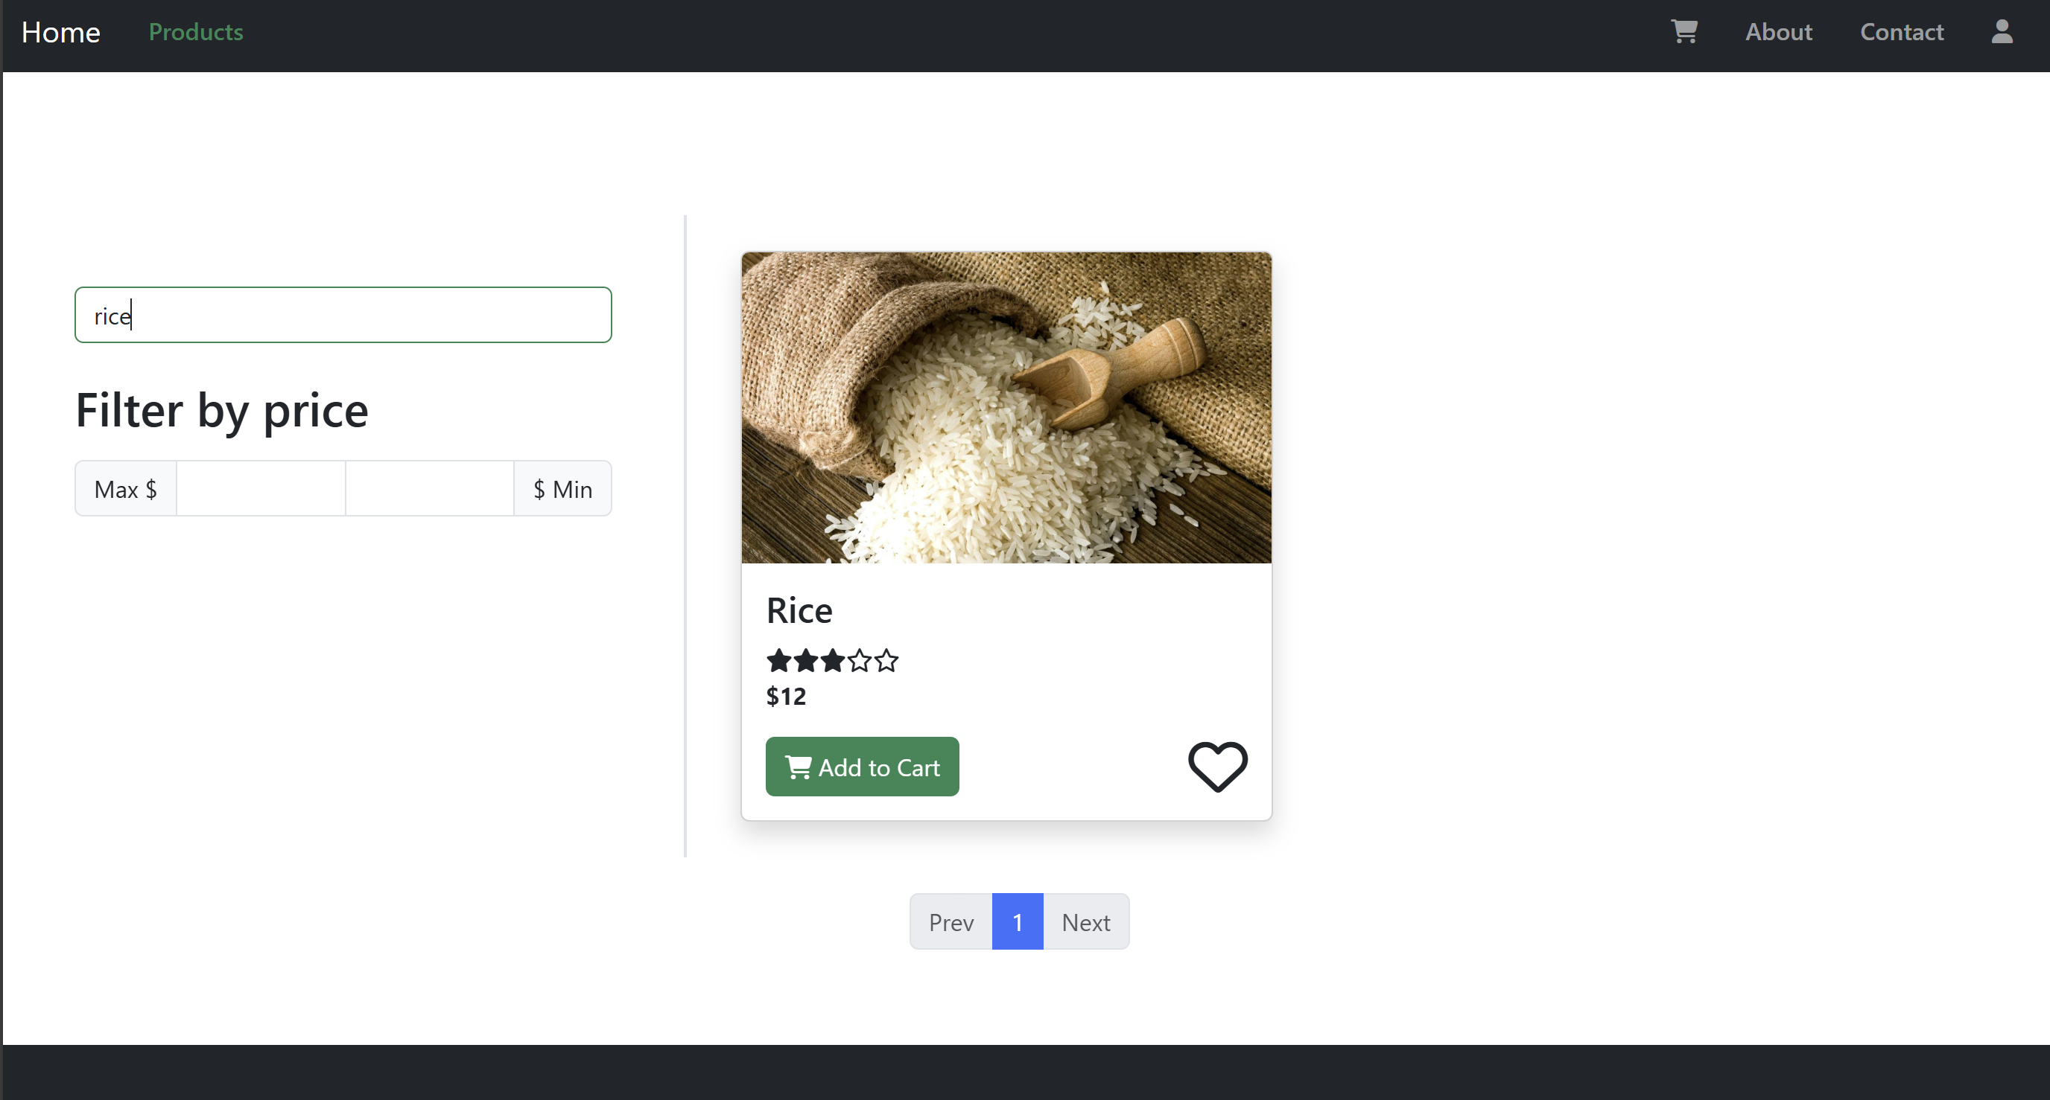

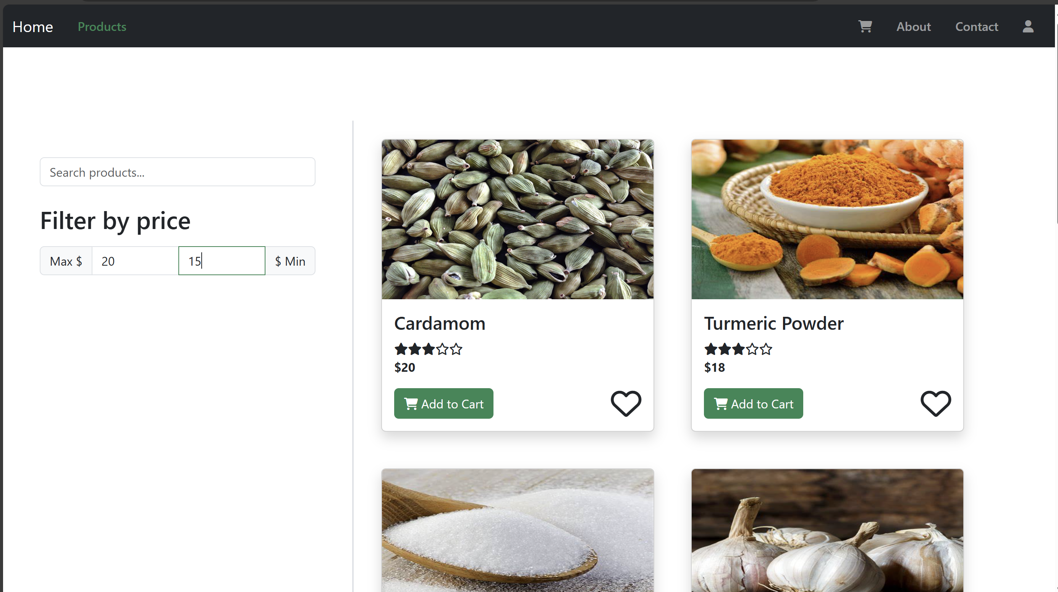

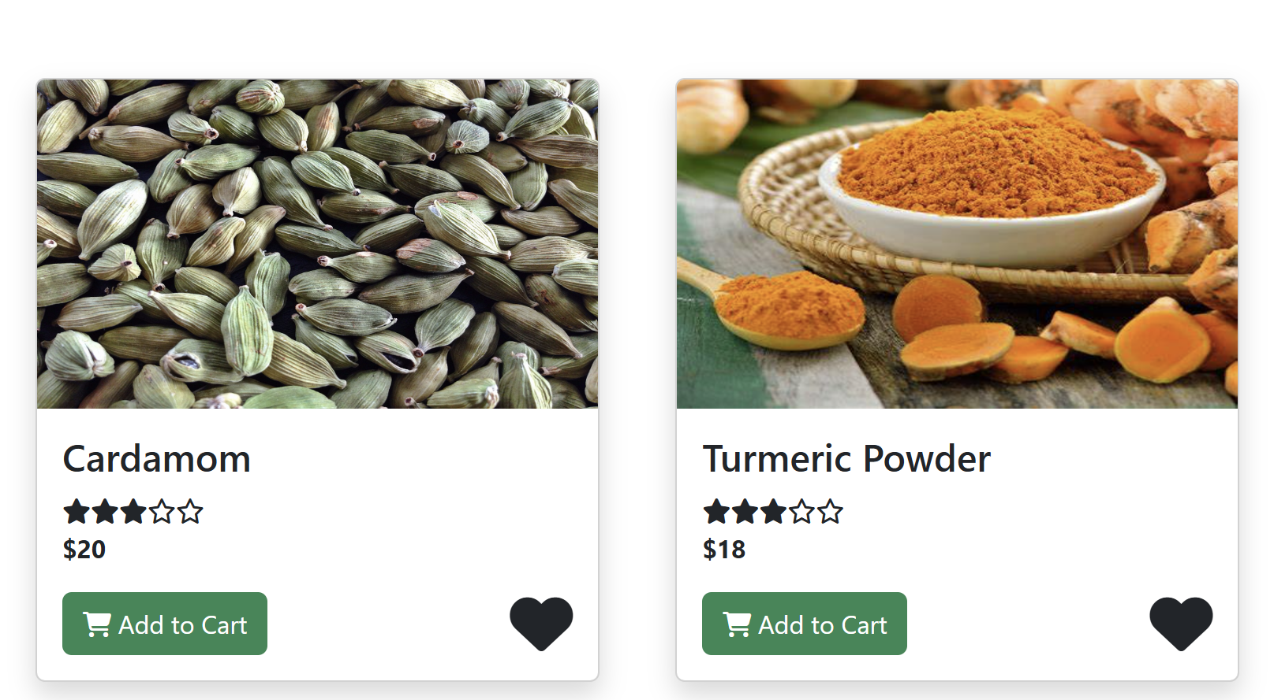

4.3 Cart Page:

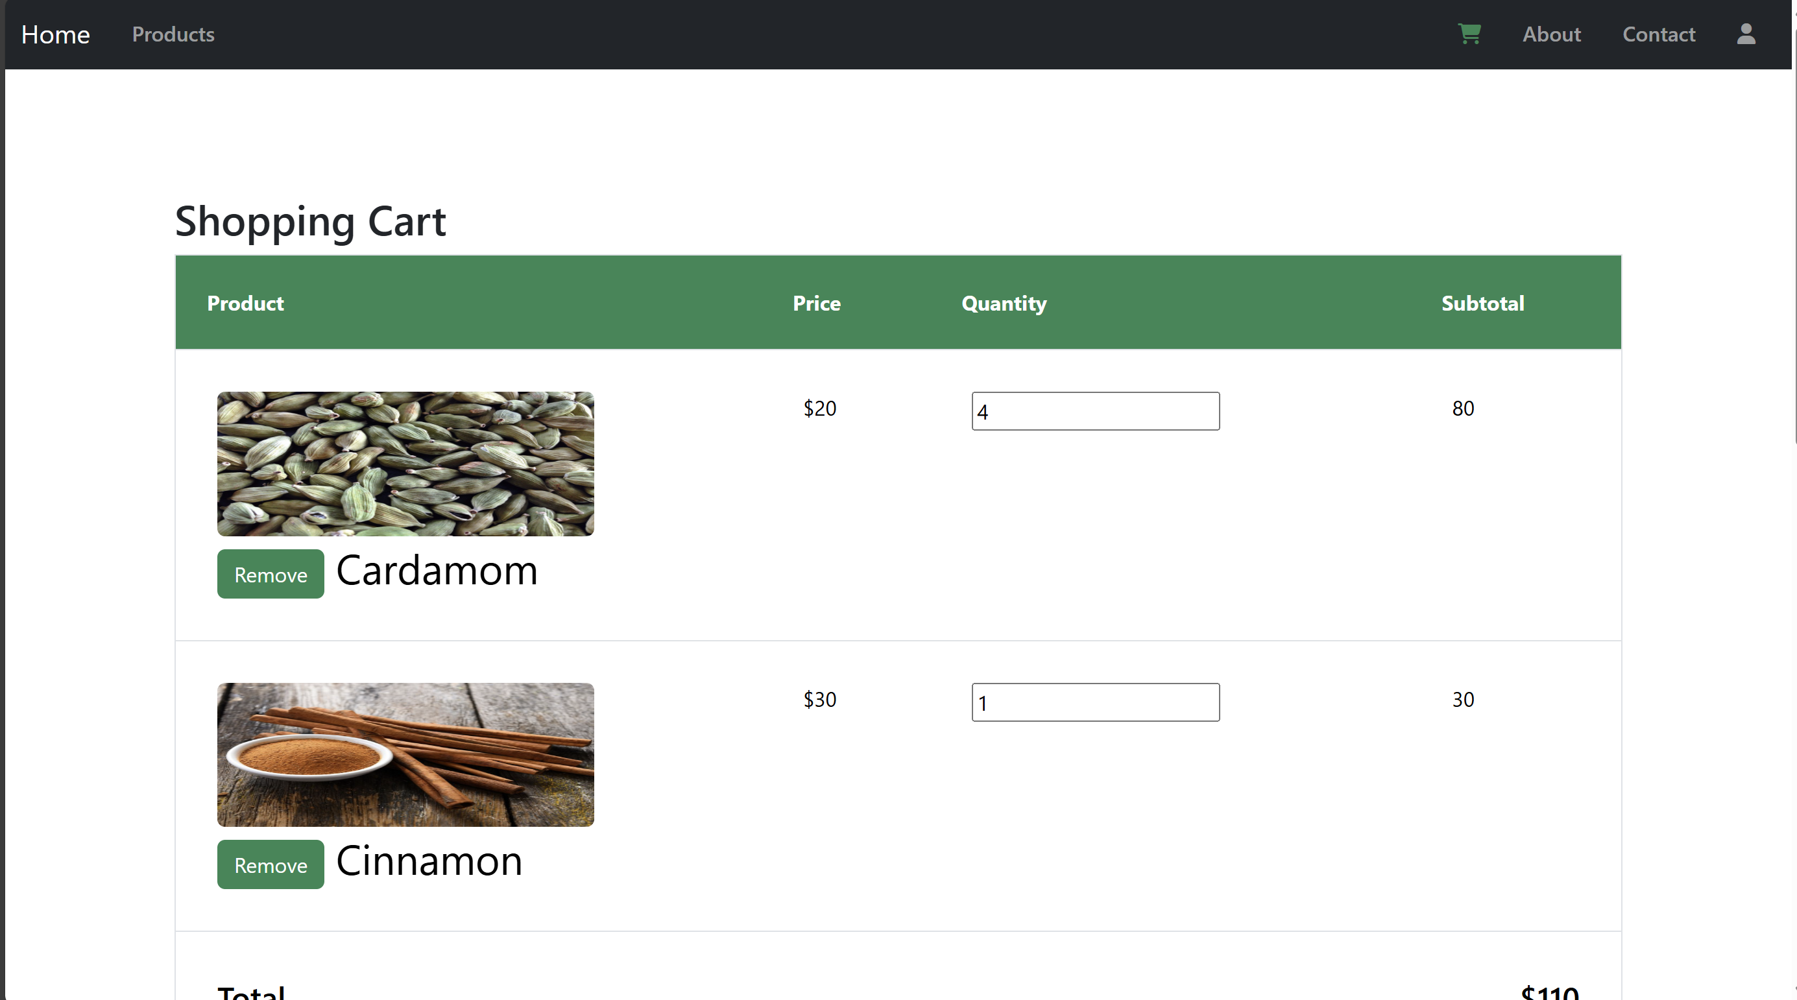

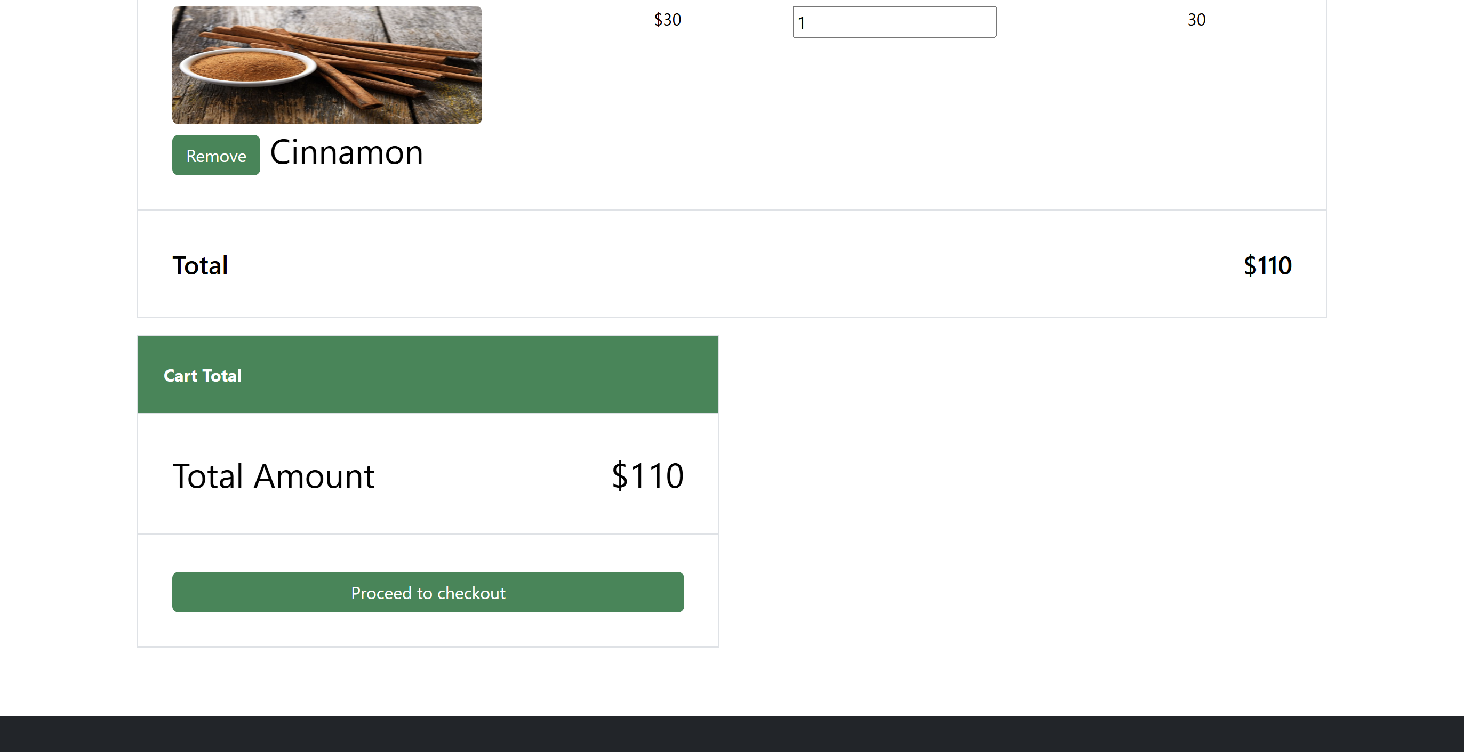

4.4 Checkout Page:

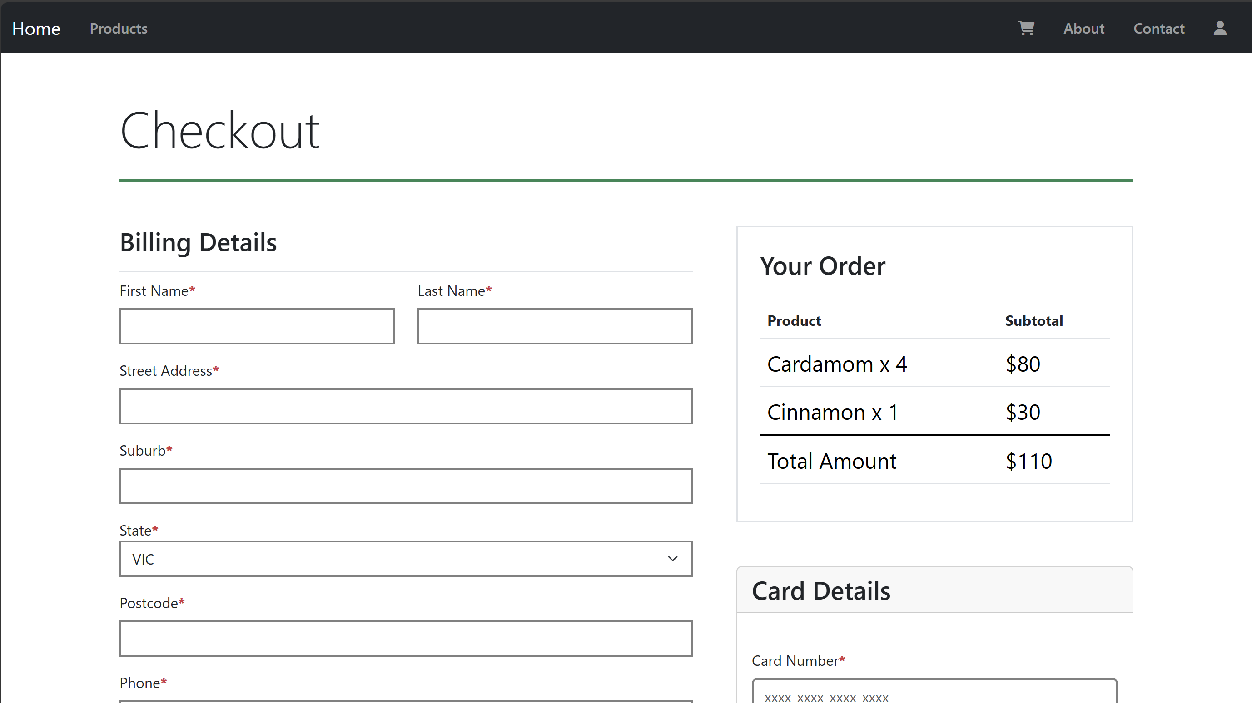

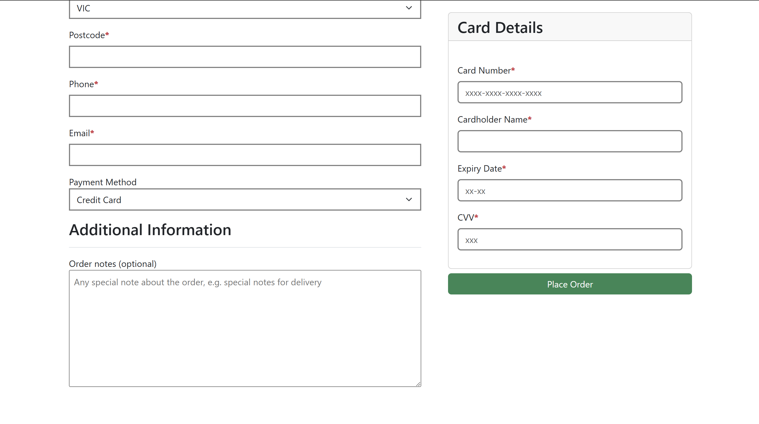

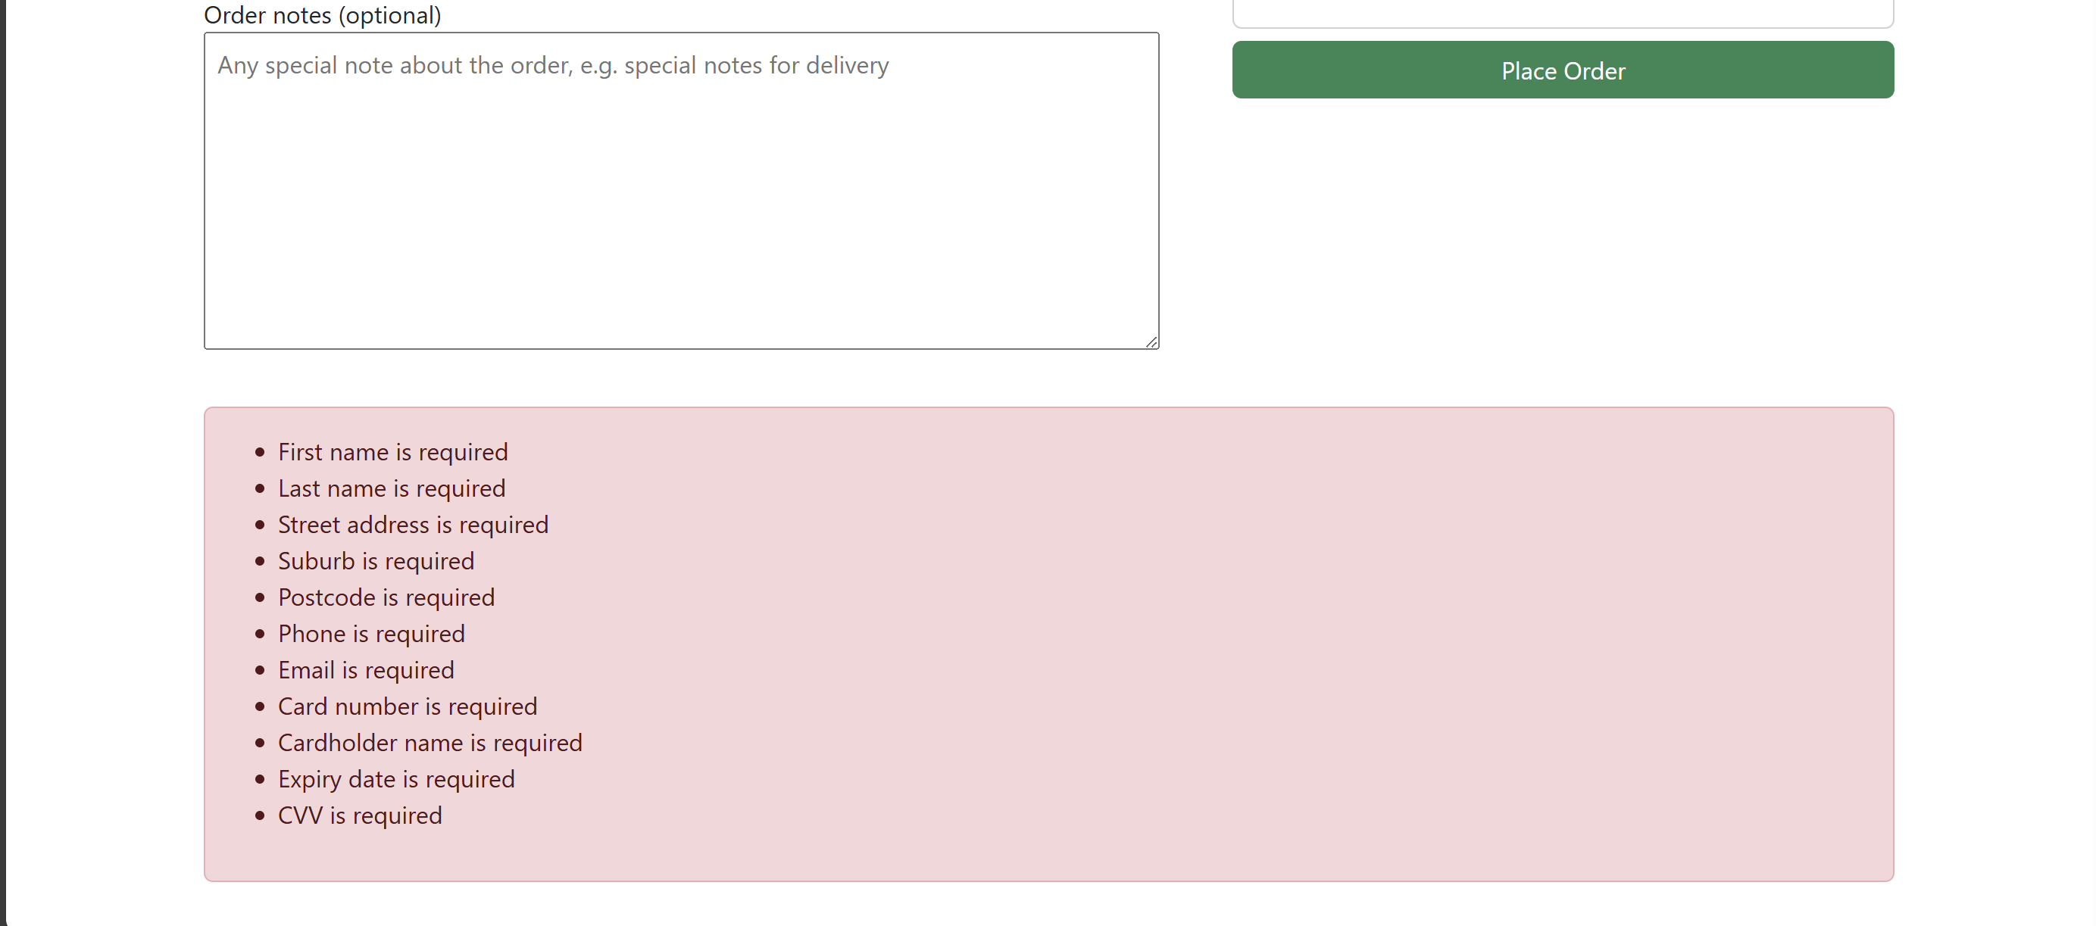

4.5 About Page:

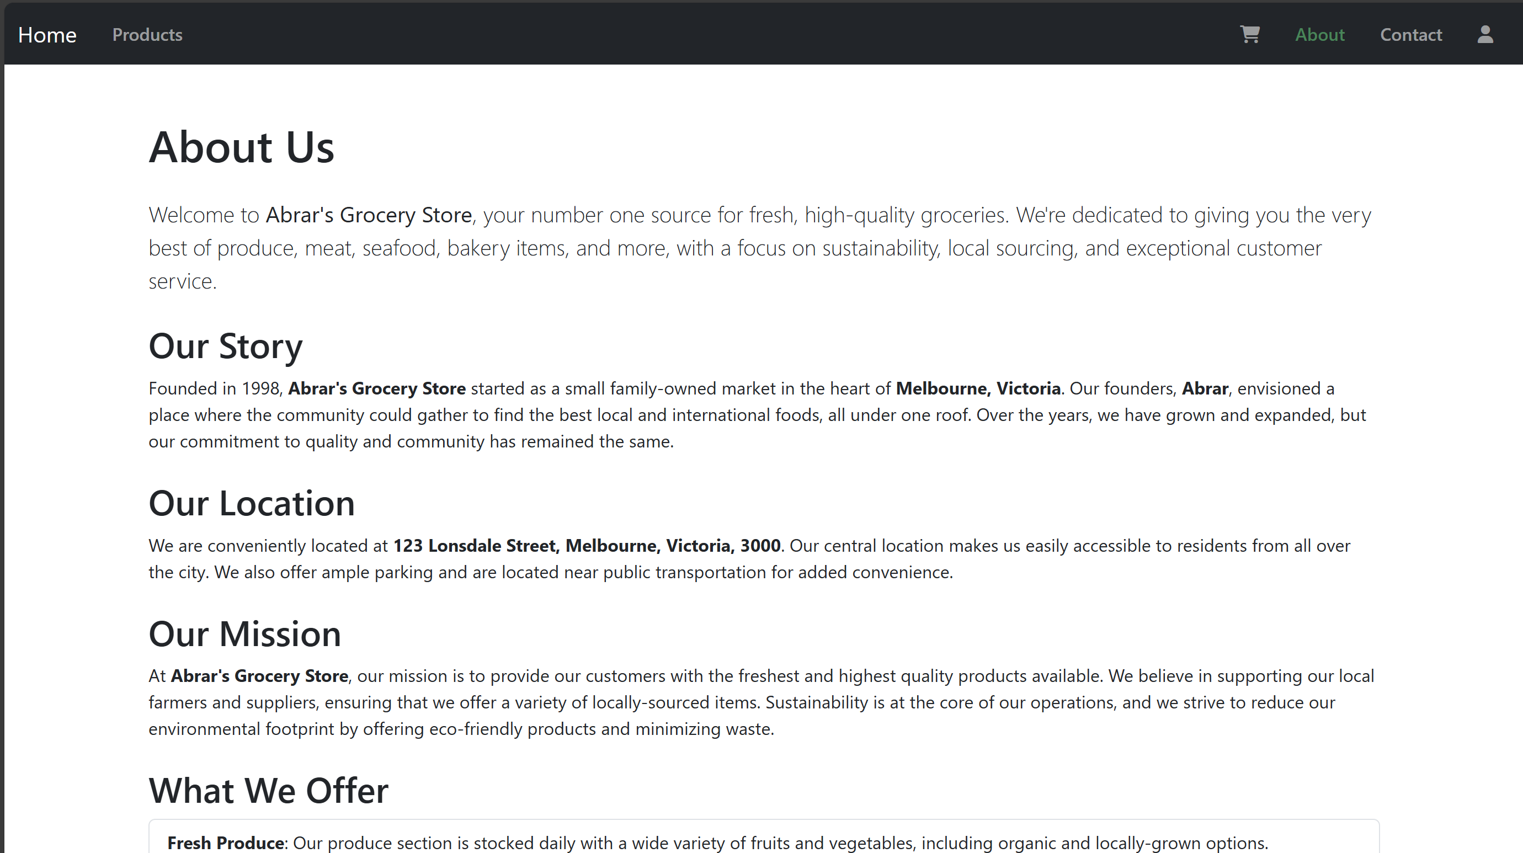

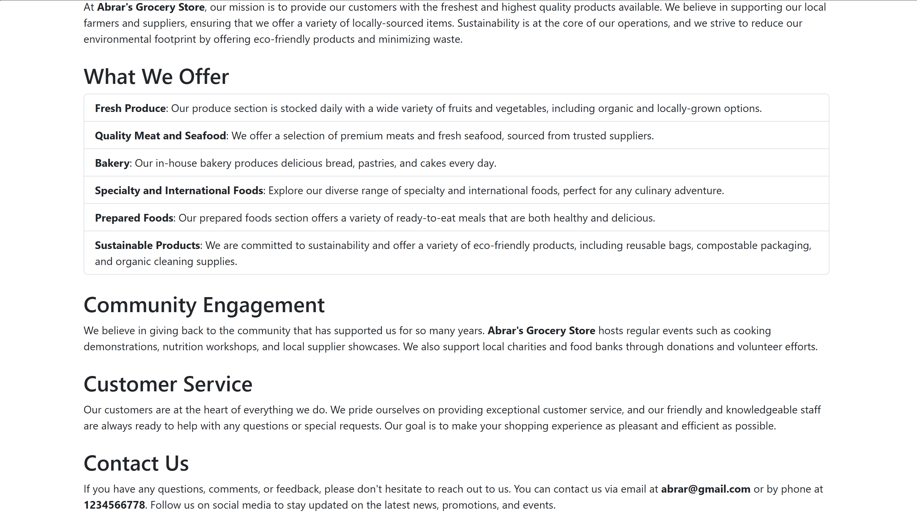

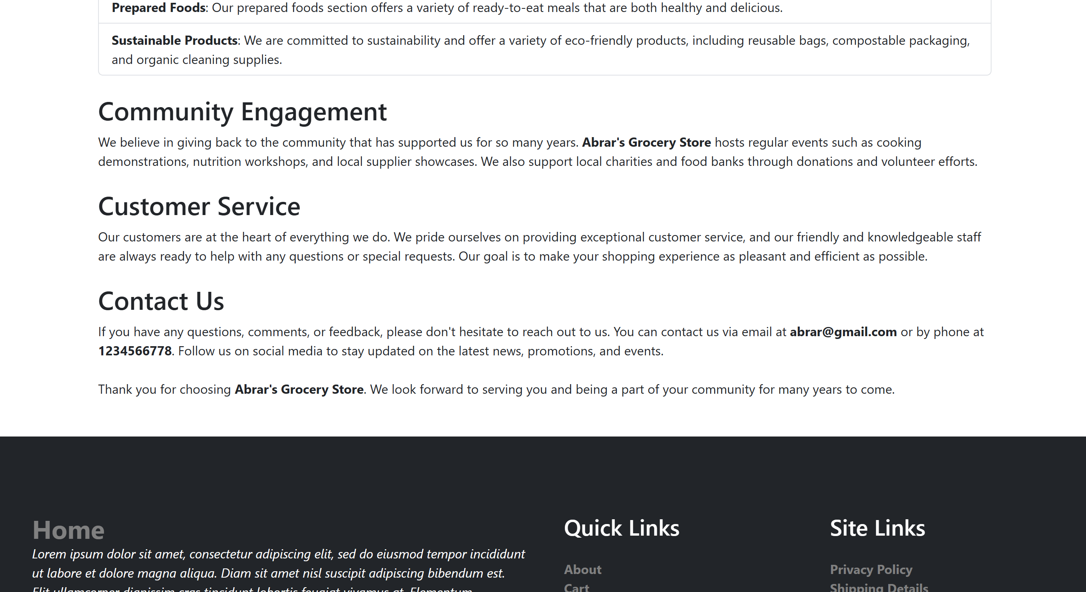

4.6 Contact Page:

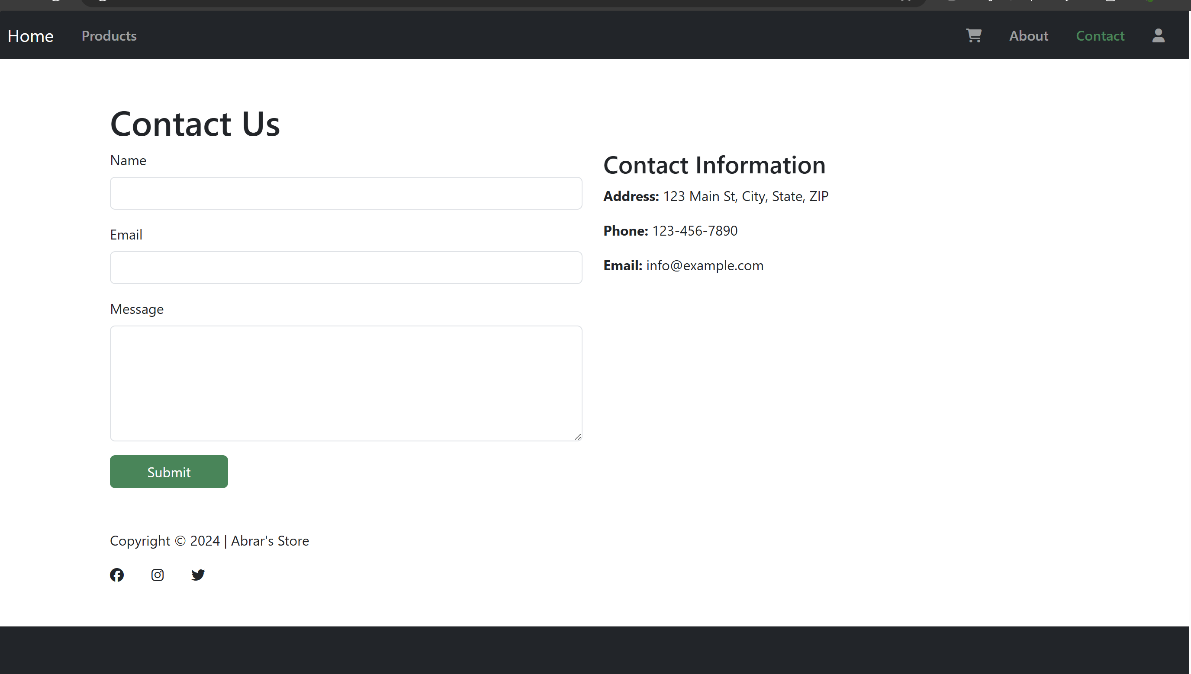

4.7 Register Page:

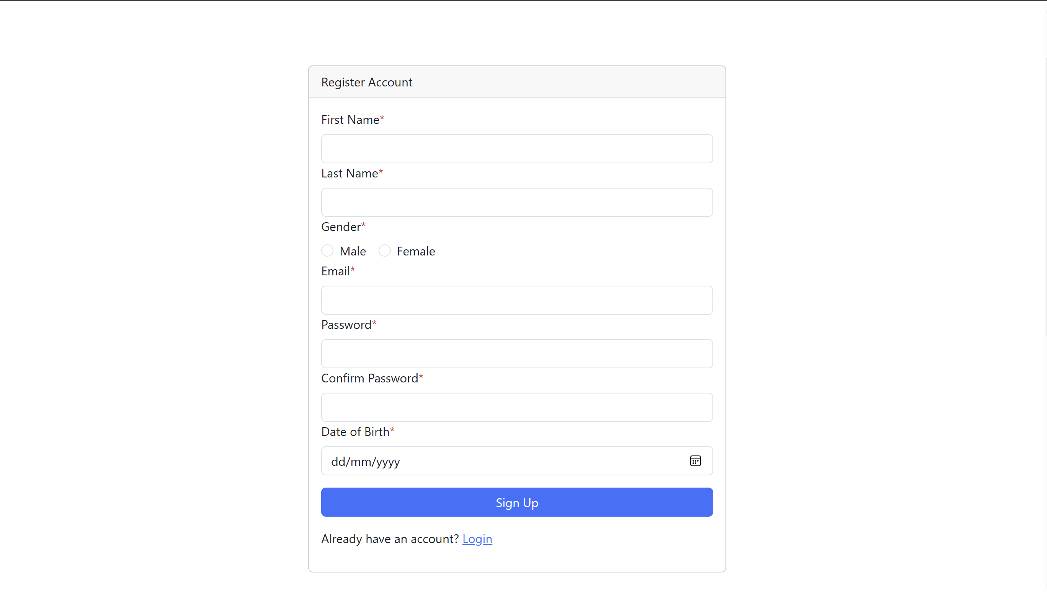

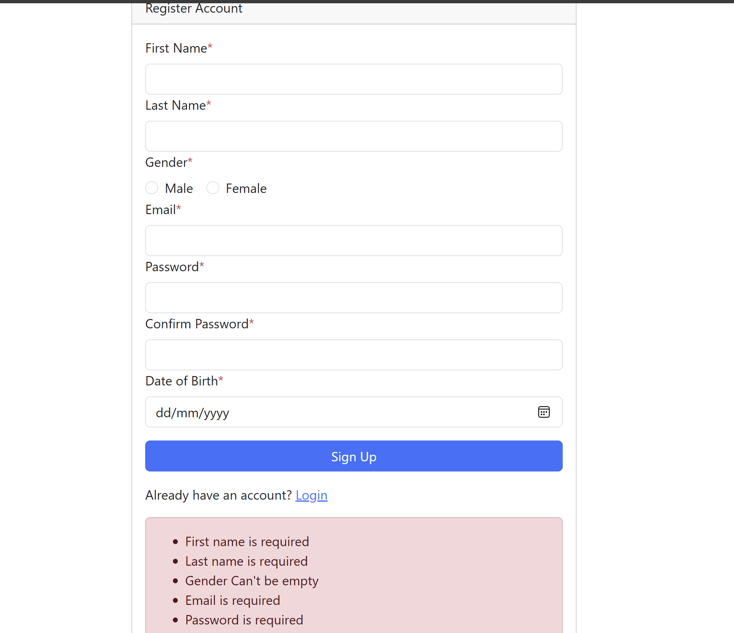

4.8 Login Page:

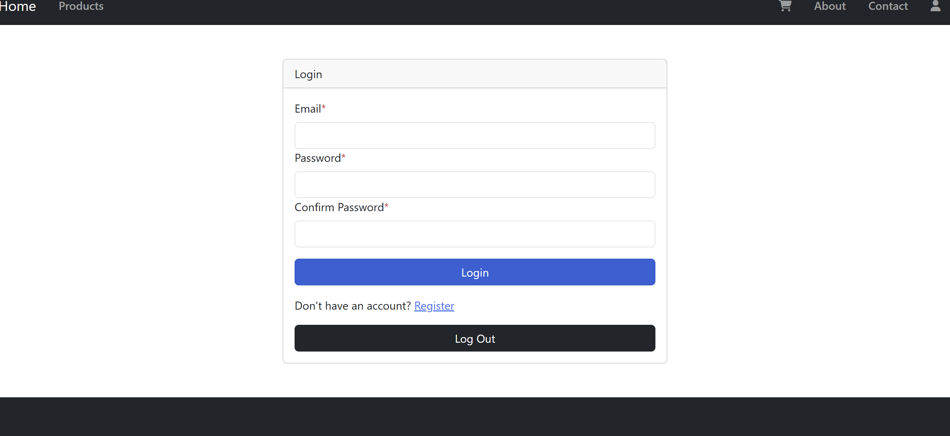

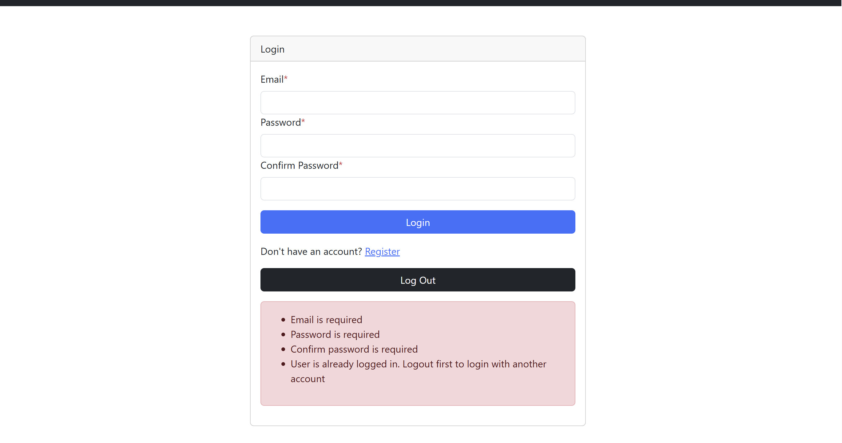

4.9 Admin Page:

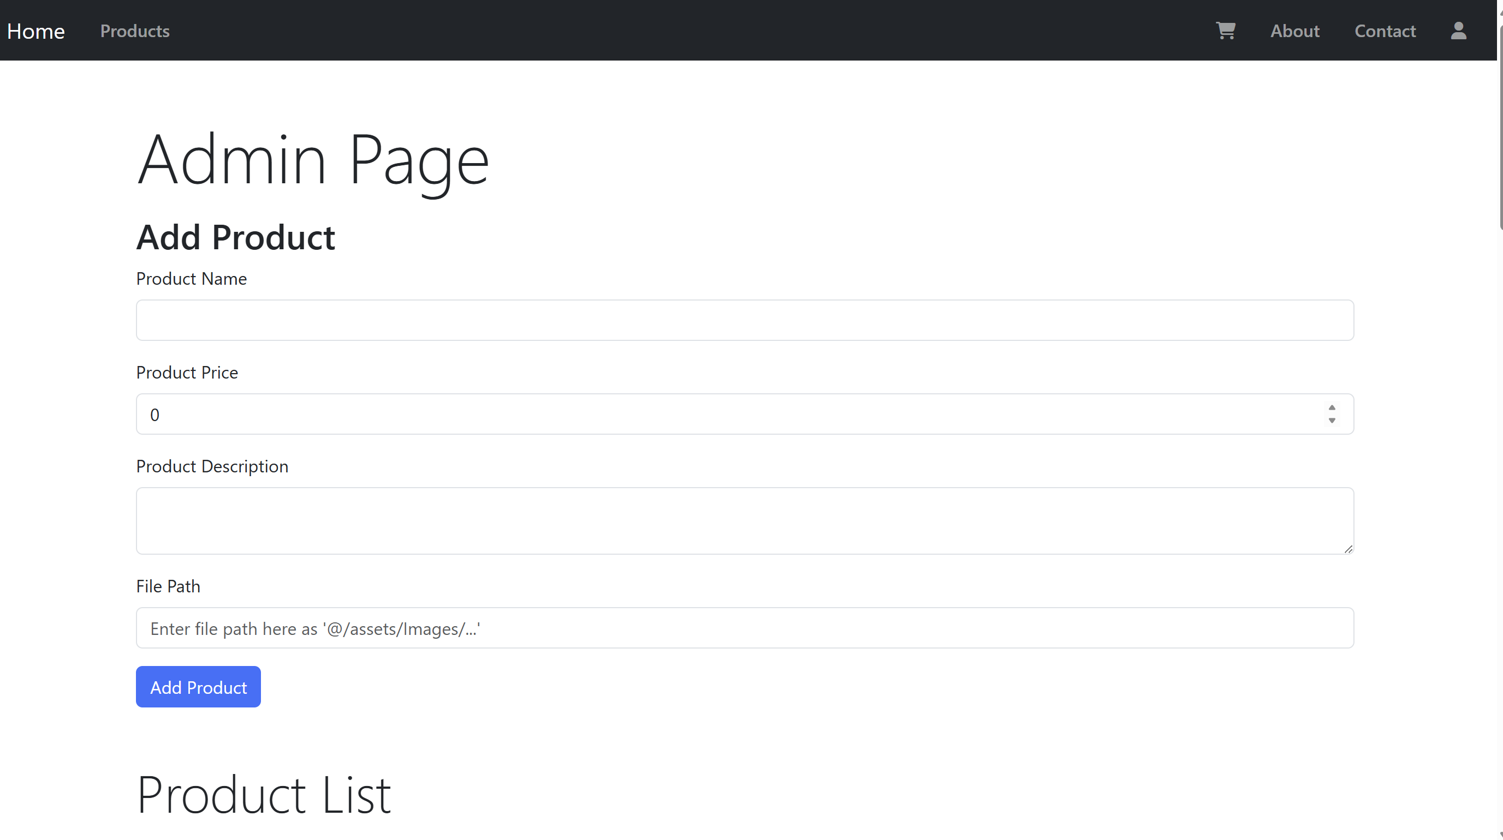

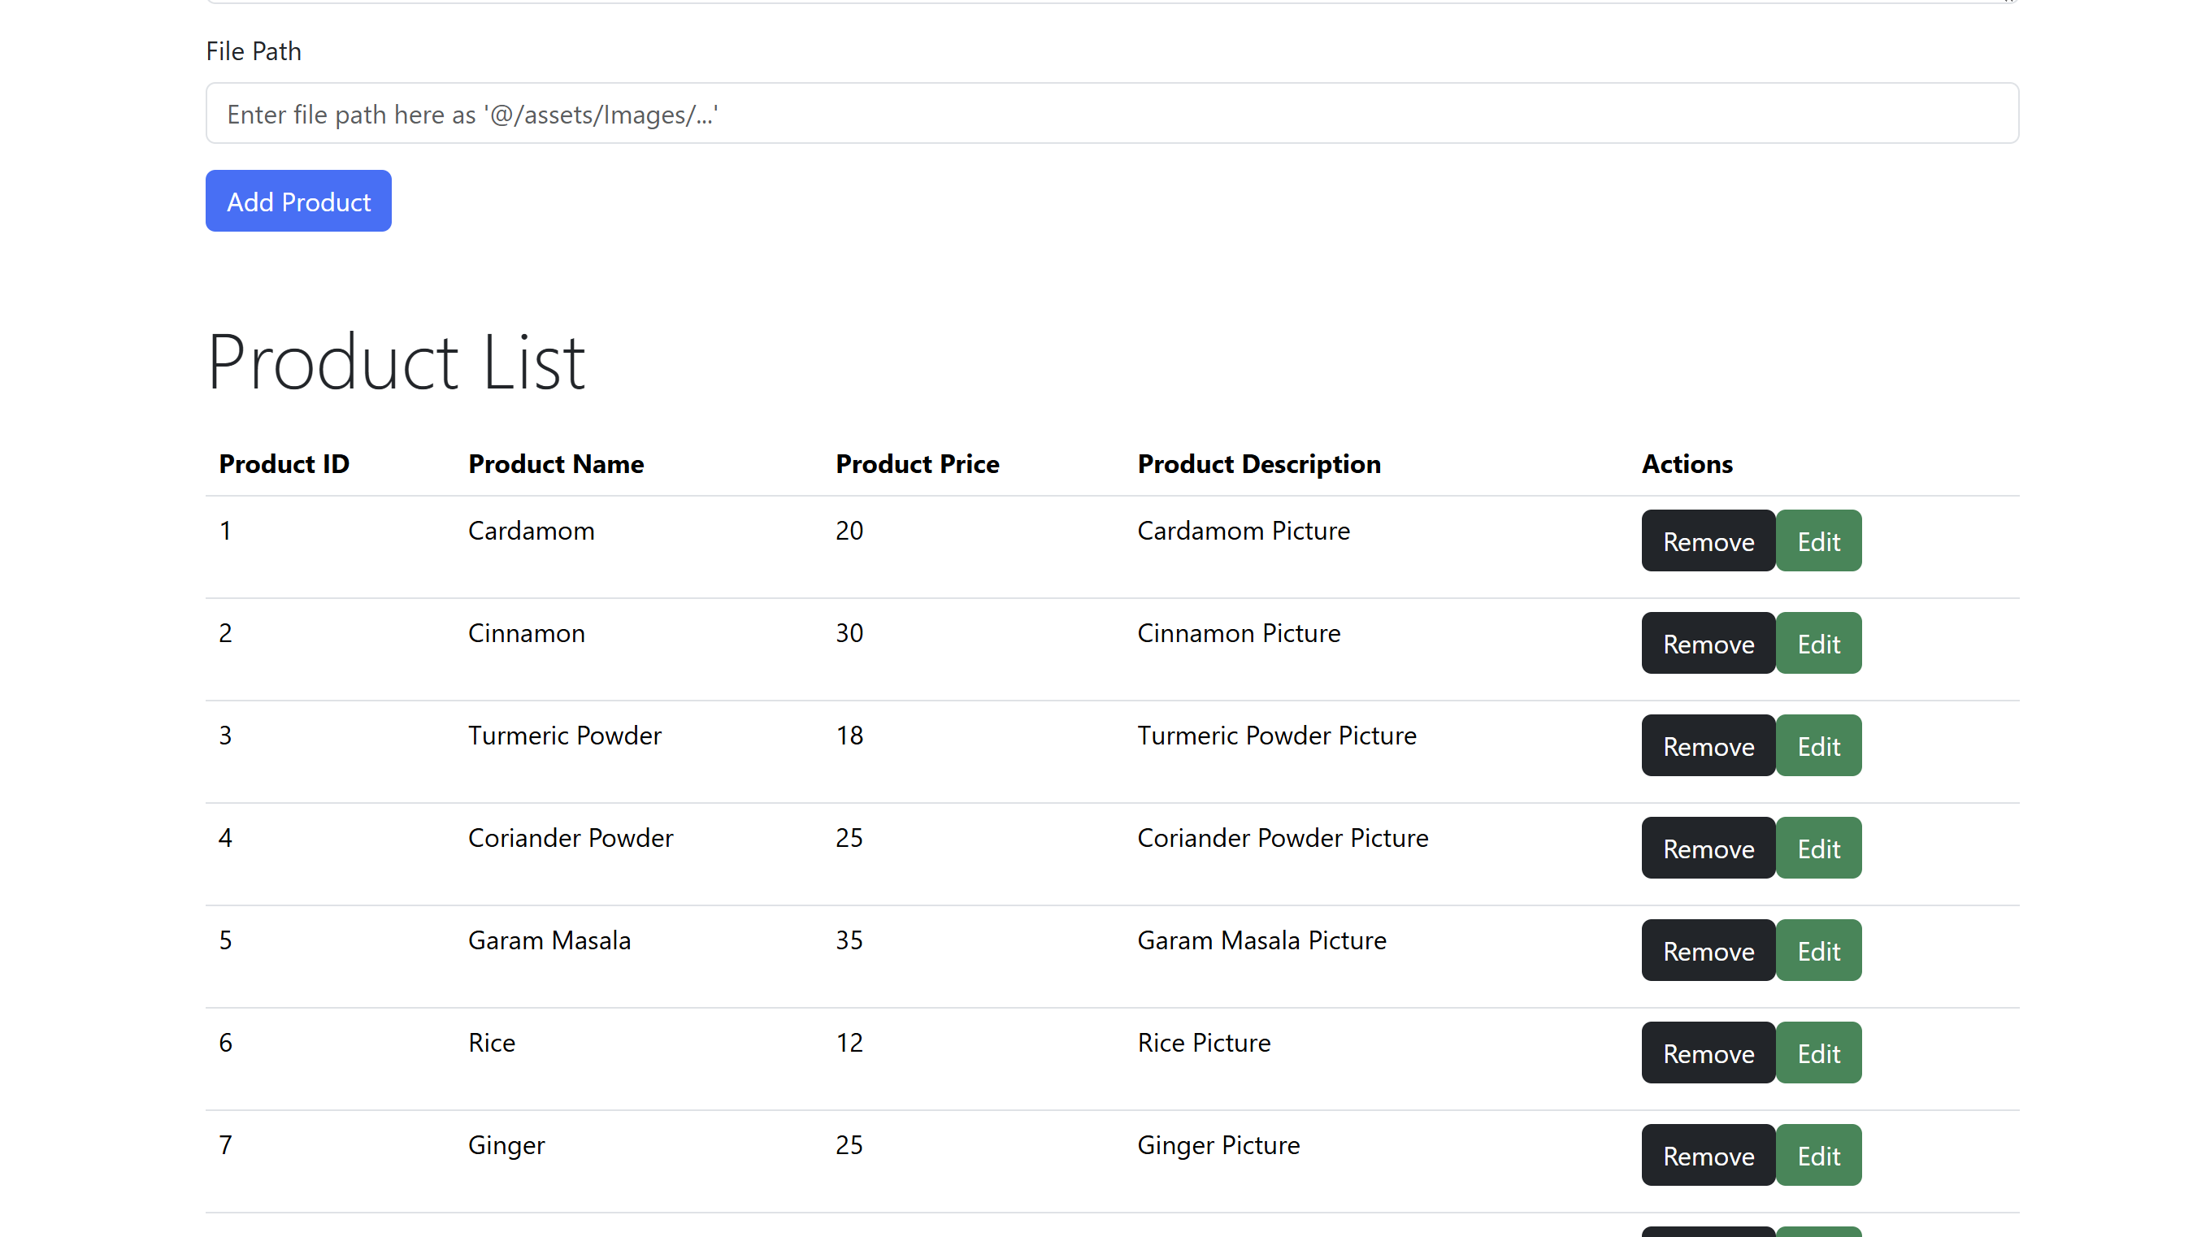

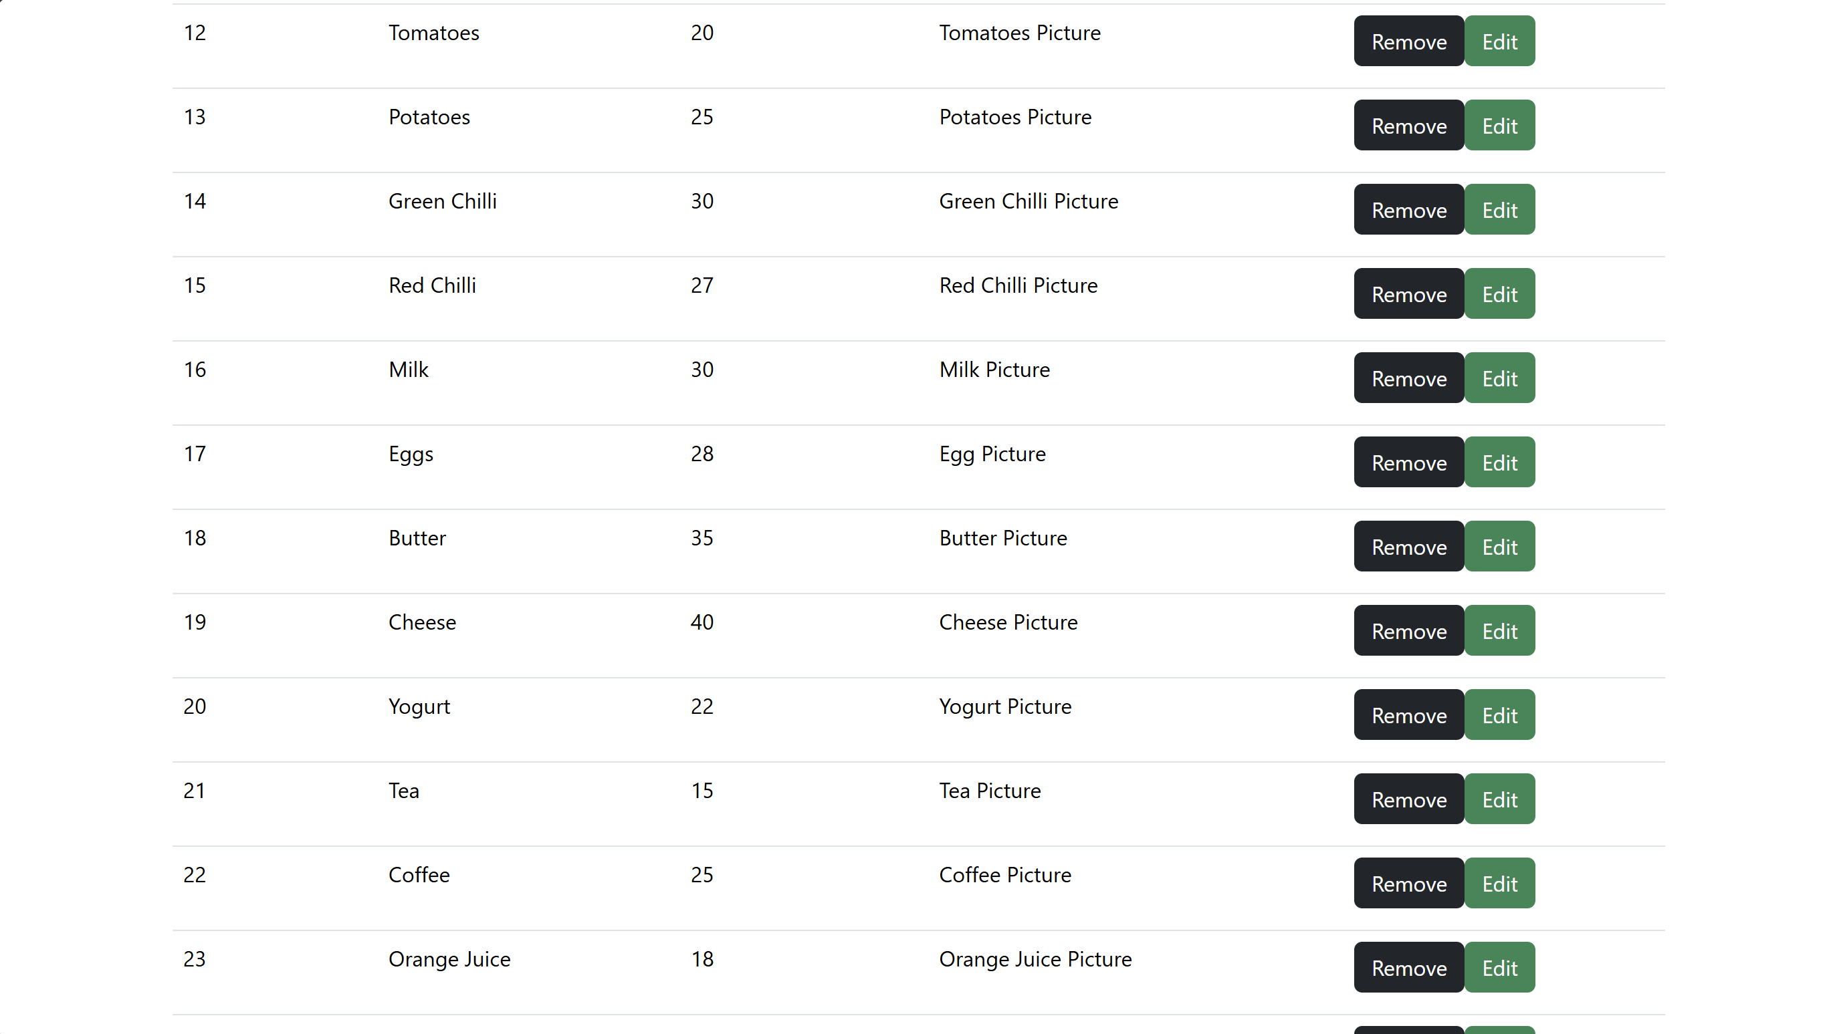

4.10 Order History Page:

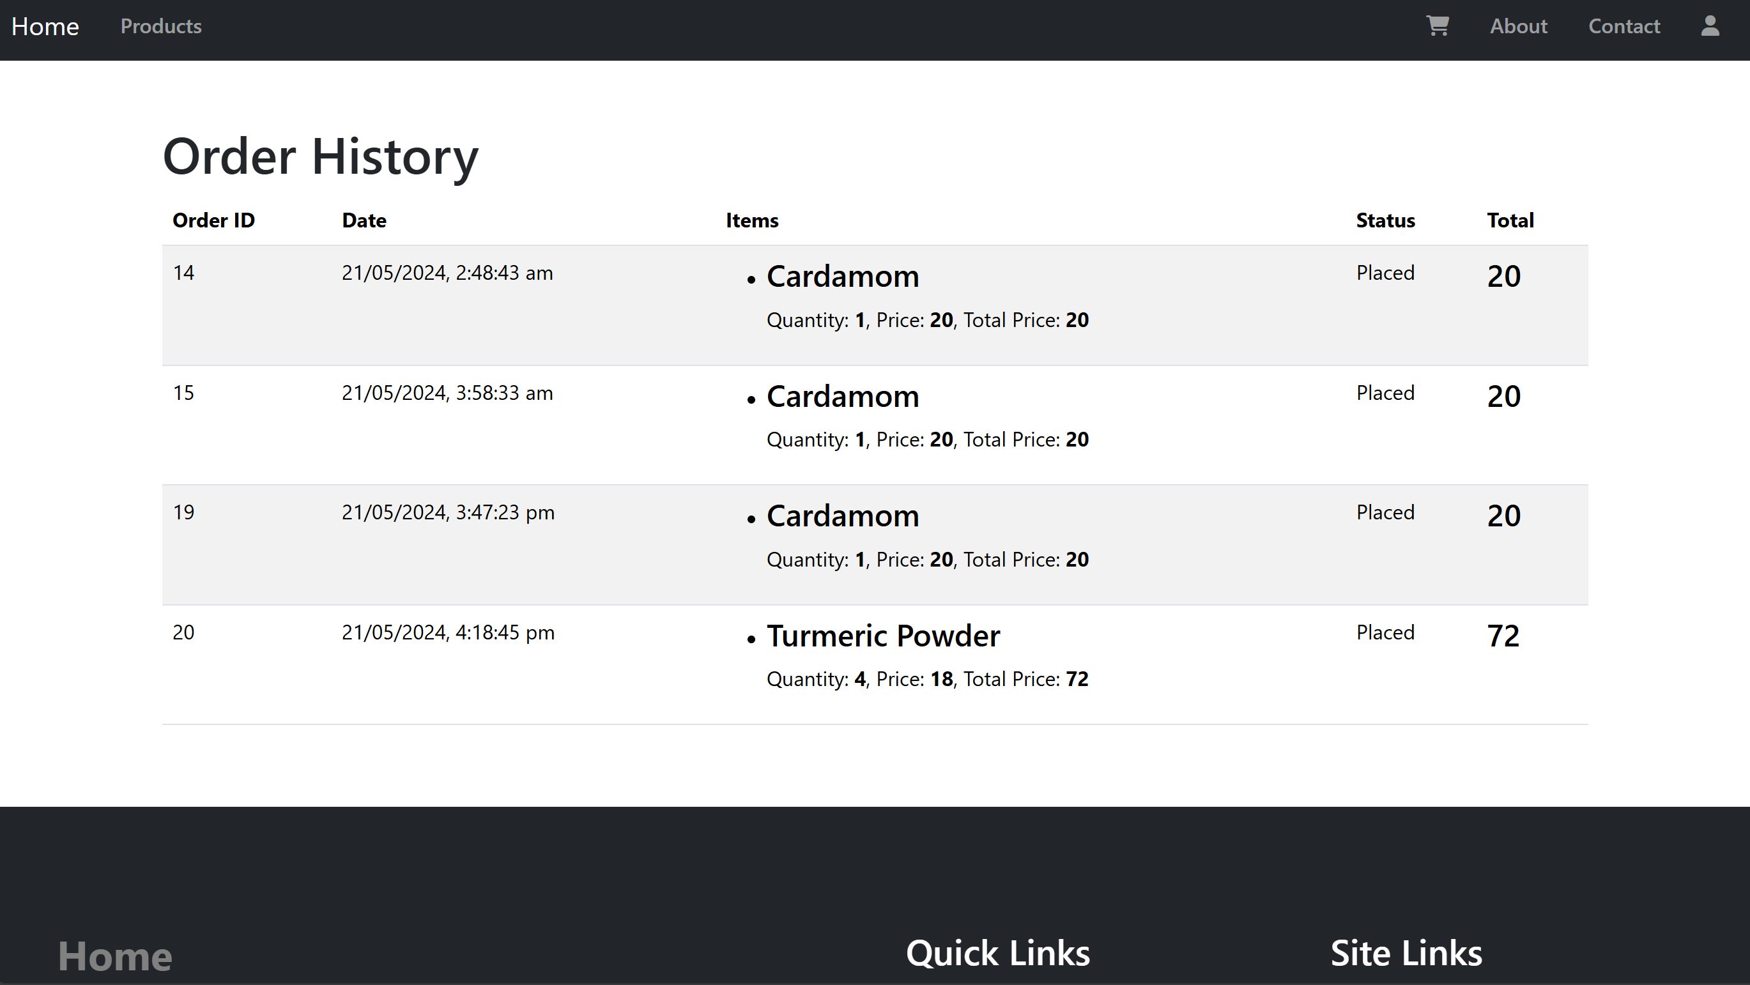

4.11 Pages Adaptive to Mobile Device:

